Cyber Security – Password and Authentication

Cyber Awareness Campaign - Part 3
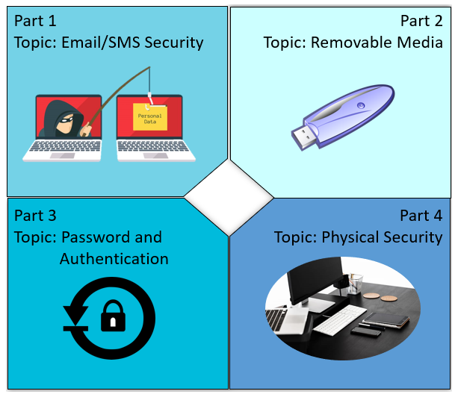
Cyber Security is the practice of maintaining
confidentiality, integrity, and availability of digital
assets like data and devices.
A cyber-attack is when a malicious third party
intentionally infringes on these principles for the
purposes of impacting a business or organization,
usually with the intent to extort money or sell data.
What is the G.James Cyber Defence system?
Defence | Description/recommendation
Username & Passwords | Should contain up to 8 characters including capitals, symbols
Multi-Factor Authentication (MFA) | Code sent to a phone or email to verify your identity
Network & Device Defence Systems | Anti-virus, Firewalls, Alert Monitoring, Anti-spam
Policy procedure and practice. | Well-defined practises and user knowledge is always the strongest defence.

Cyber security is a team effort.

Passwords
Passwords are an authentication method used to ensure that the correct people are viewing and manipulating systems they are authorised to do so. Passwords are commonplace in all our lives, with applications like banking and email.

Risk of compromise
When bad actors gain access to credentials they have access to those systems, if this is your bank account then they likely have your money. When bad actors gain access to a work account, they may attempt to exfiltrate company data, steal money or sabotage systems.

Complex passwords
Computers allow bad actors to attempt to guess the passwords, by systematically trying common passwords and variations on words and names. This process is called a brute force attack, brute force attacks can usually crack basic passwords like: ‘Password?’, ‘Ninja’, ‘Landcruiser’ in minutes.
By adding numbers, symbols and randomicity to the password, you make the task of guessing the password astronomically harder.

Multi-Factor Authentication (MFA)
MFA is a process where a user has to authenticate successfully in multiple different ways to decrease the likely hood of allowing unauthorised access to a bad actor.
Most common forms of MFA utilise mobile Phone Text messages or emails that have authentication codes, that you will be required to provide to authenticate.

Best Practices
- Do not share passwords with others.
- Do not reuse passwords across different places.
- Use complex passwords with symbols and numbers.
- Use a trusted password manager to save and generate secure passwords.
- Change passwords frequently.

What to do if we accidentally share our password
If you feel that your G.James password needs to be changed please contact the service desk to facilitate this.

Cyber security is a team effort.

There are some simple steps you can take to help:

DO Stay informed (seek the facts, not rely on speculation)

DO Attend Cyber Security Toolbox Talks and Training that will be provided

Links:
Cyber Security Policy
Intranet: Email Security Page
Intranet: Cyber Security Page
Division: |  | Branch
Workplace / Site location:
Presenter: |  | Date:

Employees Present:
Name | Initial | Name | Initial

Questions, concerns, and issues raised:

Actions:
Raised by | Description of Issue | Actions / Rectifications | Follow up required (details, person and date)
Signed: |  |  | Distribution:  - Branch Manager  - Health & Safety Coordinator
Date:

